EXPERIMENT-4

AIM: To add links, list and menu to the webpage.

LINKS:

HTML links are hyperlinks.
You can click on a link and jump to another document.
When you move the mouse over a link, the mouse arrow will turn into a little hand.
Links are found in nearly all web pages. Links allow users to click their way
from page to page.
A link does not have to be text. It can be an image or any other HTML element.

Code:

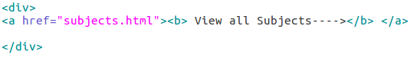

Output:

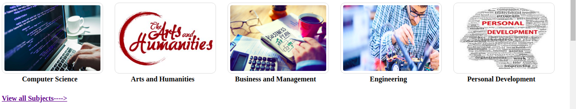

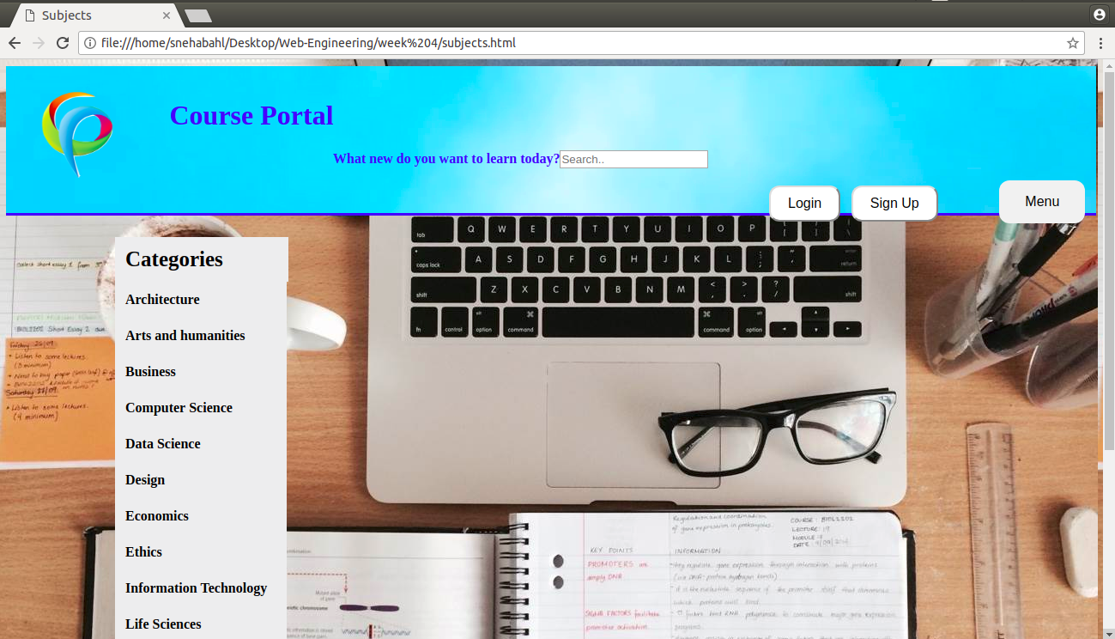
Code:

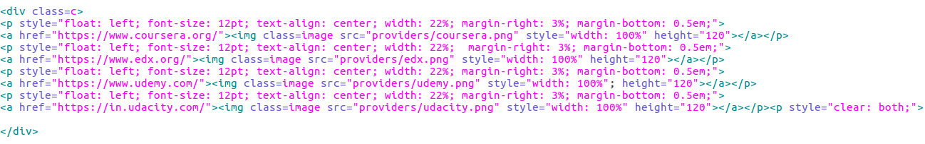
Output:


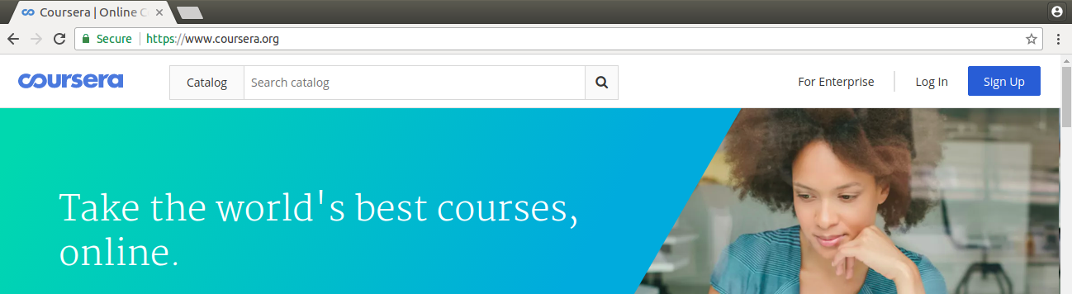





MENU:

The <menu> tag defines a list/menu of commands.
The <menu> tag is used for context menus, toolbars and for listing form controls and commands.
This tag has been deprecated in HTML and redefined in HTML5.

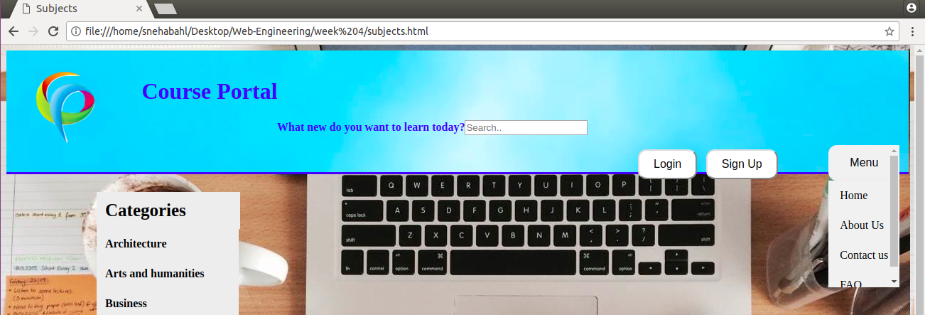

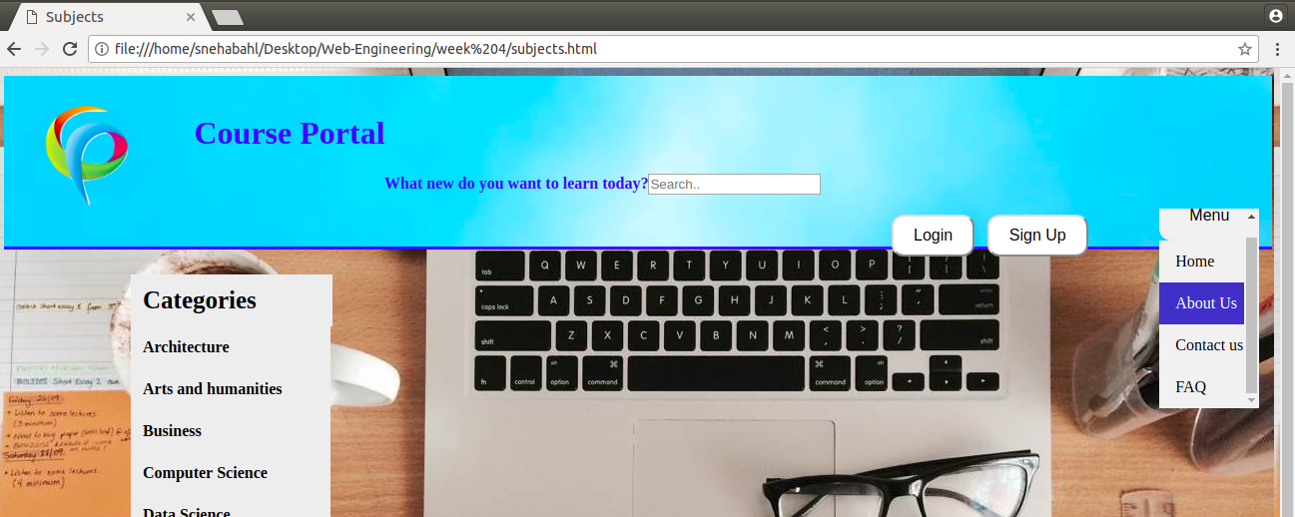
Code:
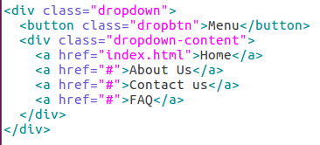

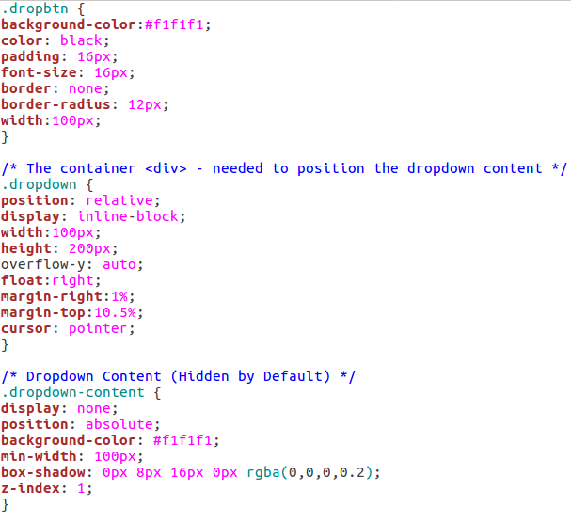

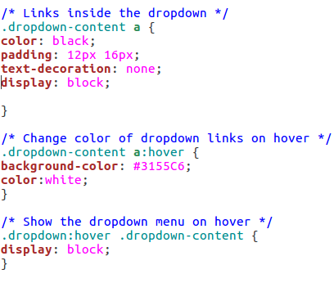

LIST-

- ORDERED LIST

An unordered list starts with the <ul> tag. Each list item starts with the <li> tag.
The list items will be marked with bullets (small black circles) by default.
The CSS list-style-type property is used to define the style of the list item marker
Value | Description
disc | Sets the list item marker to a bullet (default)
circle | Sets the list item marker to a circle
square | Sets the list item marker to a square
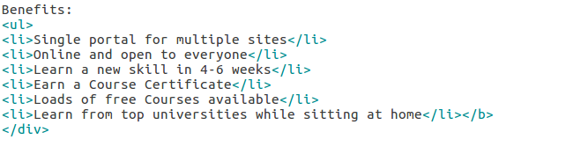  none | The list items will not be marked
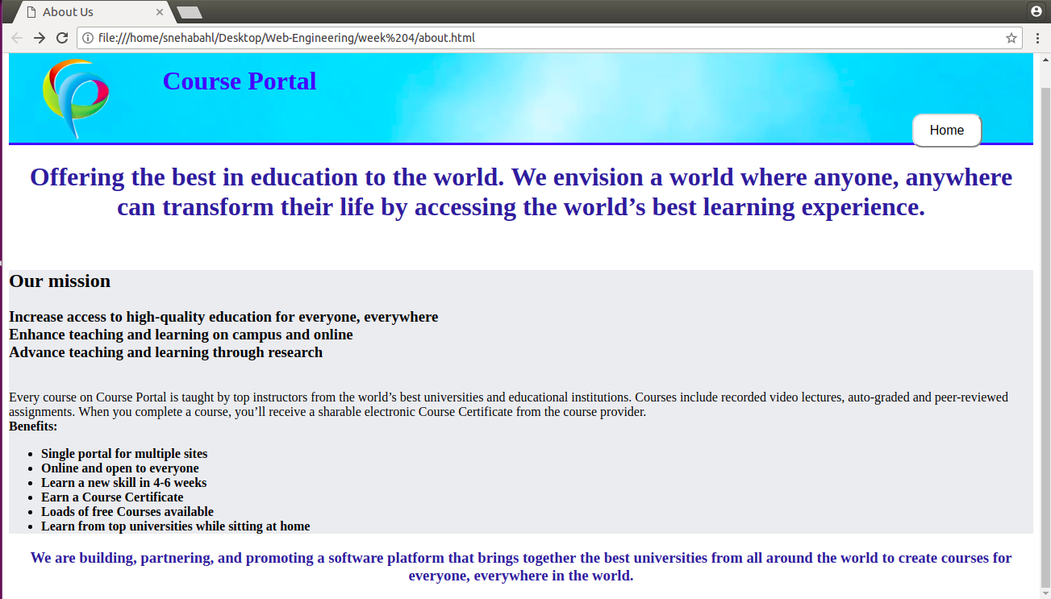
- UNORDERD LIST

If you are required to put your items in a numbered list instead of bulleted, then HTML ordered list will be used. This list is created by using <ol> tag. The numbering starts at one and is incremented by one for each successive ordered list element tagged with <li>.

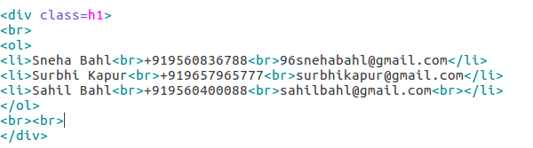

Css:
